PRAY AGAINST ASSASSINATION OF TR__MP
November 22nd, 2022

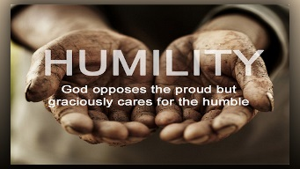
Dear Heart Dwelling family, this is an urgent plea for us all to get into intercession for Donald. Ezekiel has been suffering for him for three days, he has had several different visions of Donald being assassinated and we need to pray for him that this will not happen.

In the first vision, Ezekiel was in an open coffin and Donald was in the lid of the coffin and Donald extended his hand down to Ezekiel’s heart, where the Blessed Sacrament was lying on his chest in a golden pyx. Donald’s arms were very thin and cold.

Ezekiel realized that he was in the coffin trying to keep Donald from falling into it, from the lid into the coffin. I think this symbolizes our intercession or Ezekiel’s intercession for Donald, which Ezekiel has been suffering extreme pain for several days.

At some point in this vision, Donald gave Ezekiel the keys to his car and said, “Drive Melania home.” As he was pulling out and driving, Melania was sobbing and grieving so loud and so bitterly, he had to pull over the vehicle and just hold her to comfort her.

Now twice, Ezekiel has seen Donald no longer in his body, lying on the floor of the kitchen with a clean head shot, gunshot wound to his head, but there was also some kind of vision of Donald being shot in the temple and another man coming to fire a pistol by his temple to make it look like a suicide.

These are different plans, apparently, that are being hatched right now to kill him. Then he had a scene that switched to a library in Europe somewhere, the men were wearing cardigan sweaters, well dressed, and they were discussing four different plans to assassinate Donald.

Now tomorrow is the anniversary of President Kennedy’s assassination. We need everybody praying, everybody praying as much as you can for Donald and for his family.

Ezekiel also had another vision of Donald recovering from the attempt, but the left side of his body was paralyzed. Like Teddy Roosevelt, he was still the President, but he was injured seriously, but we do not know what God has in mind, our prayers are powerful, so please, please, please, pray for him, pray for protection for him, pray for the best possible outcome.

Thank you, Heart Dwellers. Thank you for listening and praying.

